* **Lab Task 1**

### Display the Highest, Lowest, Sum, and Average Ticket Price

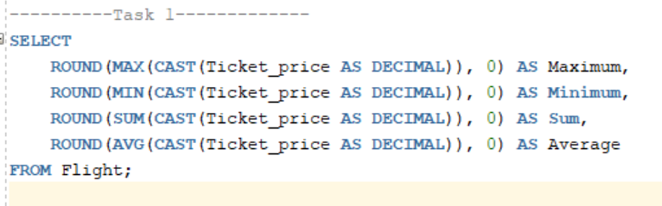

Output:

